The Alaska Commission on Postsecondary Education needs your help to inspire young Alaskans to pursue education after high school by volunteering through Virtual or In-Person Kids2Careers Postsecondary and Career Training Panel Discussions. These panel events are partnership activities between Alaska Commission on Postsecondary Education and Alaska 529. Guidance, tips and brief training videos are available to volunteers.
Kids2Careers volunteers will connect with 5th-12th grade classrooms, and share their own educational and career experiences as part of a 3-5 person College & Career Training Panel.
Volunteers will be asked to discuss topics in 1 of 4 different Tiers, as selected by the Educator.
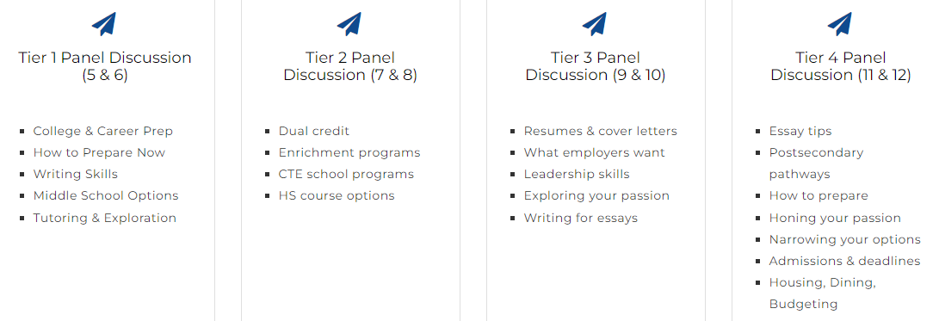
Panelists speak for 5-10 minutes and participate in Q&A with students.
**For rural Panels, we prefer panelists with connections to the community or region.**
Sign up TODAY to volunteer!
https://www.surveymonkey.com/r/ACPE_VirtualVolunteer
Volunteer Shifts Currently Available in Anchorage & Girdwood
*Zoom events are highlighted; hybrid events may be available*
DATE | TIME | SCHOOL | VOLUNTEERS NEEDED
Wed., Mar. 4 | 9:45am – 11:00am | Nuiqsut & Point Hope Schools  Zoom | 2
Wed., Mar. 18 | 9:15am – 10:30am | Klatt Elementary | 1
Fri., Mar. 20 | 9:45am – 11:00am | Chevak School  Zoom | 4
Fri., Mar. 20 | 1:45pm – 3:00pm | Creekside Park Elementary | 3
Tues., Mar. 24 | 9:15am – 10:30am | Spring Hill Elementary | 3
Fri., Mar. 27 | 1:45pm – 3:00pm | Meadow Lakes Elementary  (Wasilla)* | 3

Kids2Careers is a partnership activity of the Alaska529 and Alaska Commission on Postsecondary Education. This program needs volunteers like you!

Preparing today’s youth for tomorrow’s careers through exploration & planning

