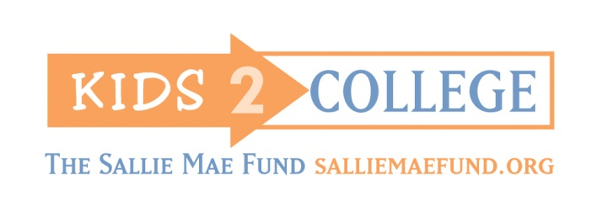
2014-2015 Kids2College
VOLUNTEERS NEEDED
If you have any questions, please contact:
Shelly Morgan at 907-269-7972; shelly.morgan@alaska.gov

Help Inspire Young Alaskans to pursue higher education!

Volunteer Shifts Currently Available in Anchorage
DATE | TIME | SCHOOL | VOLUNTEERS NEEDED
Tues., Feb. 24 | 2:00pm – 3:00pm | Mountain View Elementary | 1
Wed., Mar. 25 | 1:20pm – 2:30pm | Creekside Park Elementary | 6
Kids2College is a partnership activity of the University of Alaska College Savings Plan and Alaska Commission on Postsecondary Education. This program needs volunteers like you!
College is possible – help us continue delivering this important message to Alaska’s youth.

